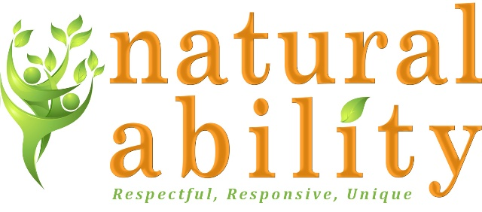

Job Description
Role | Human Resources Advisor
Reports to: | CEO
Hours: | Between 30 and 37.5 worked Monday to Friday
Workplace: | Hybrid

About Natural Ability
Natural Ability is a Registered Charity based in Hexham, that provide a range of services for adults with learning disabilities including:
- Supported Living for adults with learning disabilities
- Day Services in The Orchard our dedicated premises and outdoors in farms and gardens
- Handy Person service providing supported employment in the local area
Job Purpose:
As an HR Advisor you will be responsible for providing a comprehensive HR support to all colleagues and managers ensuring compliance with the relevant regulations and policies whilst nurturing a positive, proactive and supportive culture. You will be responsible for all recruitment activity and processing monthly payroll as well as supporting the continued development of the organisation through your involvement in implementing strategy and improvements to policies, procedures and the overall service.

Main Duties and Responsibilities:
- Providing an excellent and proactive HR advisory service to managers across the organisation.
  - Coaching and supporting managers to be confident in HR practice by offering HR advice and enabling them to manage employee relations issues.
  - Advising on the full spectrum of HR employment matters including recruitment and selection, discipline, grievance, absence management, TUPE and organisational change.
  - Research, develop and update new and existing HR policies and procedures in line with best practice and relevant employment legislation, ensuring fit for business purposes.
- Managing organisational recruitment
  - Co-ordinating recruitment processes and campaigns.
  - Supporting Service Managers with selection processes.
  - Conducting pre-employment checks and on-boarding processes.
  - Co-ordinating induction processes and mandatory training.
- Updating and maintaining HR information and systems
  - Planning and coordinating HR and payroll administrative procedures and systems and devising ways to streamline processes.
  - Supporting Service Managers and colleagues to utilise the online HR system.
  - Maintaining comprehensive records for all aspects of the employee lifecycle in line with GDPR principles.
  - Creating and updating HR documents, guidance and tools in line with legislative and organisation needs.
  - Identifying, collating and analysing people information as required to drive insight on HR matters and inform organisation decisions.
- Co-ordinating Staff Development
  - Supporting the management team with the development of an annual learning needs assessment and organisational training plan.
  - Supporting Managers with the co-ordination of e-learning and classroom-based training.
  - Responsibility for the management of the organisational training matrix.
  - Supporting the organisation with the management of the training rooms and resources which are bookable by external organisations.
- Senior Management Responsibilities
  - Support the senior management team with strategic planning and development.
  - Support with the development of organisational policies and procedures.
  - Develop and implement HR projects to support improvement and organisational changes
  - Prepare reports and statistical information for the Board of Trustees.
  - Attend and contribute to board meetings when required.
- Other duties as required by business need.
Benefits of working with Natural Ability:
- Supportive, friendly culture in a nurturing and growing organisation
- 25 days holiday plus bank holidays
- Support with personal development.
- Employer contribution pension scheme.
- Employee Assistance Programme.

Natural Ability is committed to safeguarding children and vulnerable adults and all successful applicants will need to submit to a DBS check at the Enhanced level.

Person Specification
 | Essential | Desirable
Skills, Knowledge, qualifications | Previous experience as an HR Advisor or similar role  Relevant qualification or training eg CIPD  Good understanding of UK employment law.  Relationship management skills.  Resilient and confident with strong negotiation skills.  Excellent communication skills.  Ability to travel to meet the requirements of the post. | Strong recording and report writing skills.  Understanding of GDPR principles and requirements.  Ability to write and develop policies and procedures.
Experience | Experience in coaching and advising managers in the full spectrum of HR matters including performance management, disciplinary, grievance, absence management, and TUPE.  Experience of working in a fast-paced HR environment with large staffing numbers.  Experience of establishing HR systems and tools.  Experience of working as part of a senior team. | Experience of supporting with staff personal development.  Experience of supporting a senior management team in developing organisational strategies.
Personal qualities | Commitment to the ethos of Natural Ability.  Commitment to excellent care for disabled people.  Commitment to the participation and empowerment of people with disabilities.  High level attention to detail.  Conscientious and motivated.  Sensitivity and empathy.  Positive and buoyant approach.

