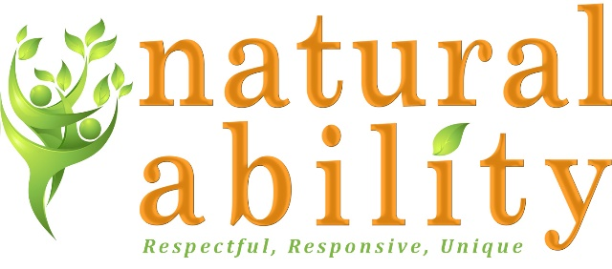

Job Description
Role | Centre Volunteer
Responsible to | Day Services Manager
Location | The Orchard, West Orchard House, Hexham, Northumberland
Commitment | We are looking for volunteers to support on a Monday and Wednesday between the hours of 9:30am and 4:30pm

About Natural Ability
Natural Ability is a Registered Charity and Company Limited by Guarantee providing agricultural and animal care work, arts, crafts and cookery skills training, and other skills development, education and Supported Living for adults with learning disabilities.
Natural Ability aims to:
- Support the personal development and autonomy of people with learning disabilities.
- Offer work which is meaningful, productive, dignified and challenging.
- Develop environmentally sustainable ways of living and working.
- Ensure that people with disabilities are seen as an important part of the community.
What Does the Volunteer Role Offer?
Job Purpose:
The role will involve supporting and assisting The Orchard activity team in the delivery of our day service to a group of people with learning and other disabilities. You will support in delivering activities both indoors and outdoors including horticulture, living & independence skills, digital skills, crafts, art, cooking, health & wellbeing, social interaction and other similar activities. Working under the guidance of the Day Services Manager and the Centre Activity Supervisors the role will actively promote the independence and skills development of adults with learning disabilities.
The Orchard Centre Day Services
The Orchard Centre currently runs day services on Monday and Wednesday and offers a range of work experience, training & opportunities and qualifications for adults with learning disabilities, including those with complex needs. Activities include, but are not limited to, gardening, environmental studies, arts, crafts, cooking, travel training, first aid, emotional skills & relationships, nutrition, exercise, graphics & design, drama & media.

Volunteer Role Description
- To support attendees in a person centred way.
  - Welcome attendees to the centre. Help to create an environment of friendly, warm, fun and positive social interaction.
  - Participate in all activities including supporting on community trips and projects.
  - Encourage people who attend sessions to interact with others where appropriate and work as a team as far as they are able.
  - Support the attendees to complete tasks, activities and records to support their learning.
- To support with the monitoring of individual progress and the overall effectiveness of the Day Service.
  - Contribute your observations of the progress made by individuals, thereby supporting Activity Supervisors to monitor and record sessions and individual performance.
  - Support individuals to identify and work through their achievement goals. Support individuals to record their experiences in a way that is preferable to them.
- Support with the Co-ordination and Development of The Orchard
  - Support Activity Supervisors to plan interesting and varied activities and programmes, support attendees to shape the Centre activity plan.
  - Support with practical tasks such as setting up for sessions and preparing refreshments.
- Manage Health & Safety and Risk
  - To understand the principles of Safeguarding and reporting.
  - To ensure that Health and Safety and all other Policies and Procedures are followed.
  - To use equipment and resources safely to meet needs of the service.
- Other duties as required by business need
  - To actively promote inclusive practice to ensure acceptance of people with disabilities in the community.
  - To have challenging expectations that encourage people to act independently and build self-esteem.
  - Attend and participate in centre meetings and participate in volunteer supervision as required.
  - Participate in training and development.
  - Comply with all Natural Ability policies and procedures in all aspects of work.
  - Maintain confidentiality according to Natural Ability’s policies and procedures.

Person Specification
 | Essential | Desirable
Skills, Knowledge, qualifications | Excellent communication skills.  Ability to work well with people with learning and other disabilities.  Understanding of the needs of vulnerable people.  Knowledge of issues around Safeguarding Vulnerable Adults.  Understanding of Confidentiality.  Ability to travel to meet the requirements of the post.  Good IT skills. | Experience in a volunteering role.  First Aid Training.  Basic Food Hygiene Training.
Experience / Interests | . | Working / volunteering with and for people with disabilities.  Skills or interests such as:  Arts and crafts skills.  Cooking skills.  Digital, graphics & design skills.  Fitness skills  Interest in Nature and the environment.
Personal qualities | Commitment to the ethos of Natural Ability.  Willingness to participate in development and training opportunities.  Creativity.  Commitment to the participation and empowerment of people with disabilities.  Reliability.  Flexible approach.  Conscientious and motivated.  Demonstrate a positive, buoyant, flexible approach to work.

Natural Ability is committed to safeguarding children and vulnerable adults and all successful applicants will need to submit to a DBS check at the Enhanced level.

