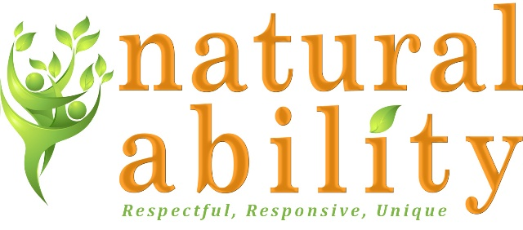
Job Description
Role | Business Support Assistant
Reports to: | Finance Manager
Hours: | Between 30 and 37.5 hours a week over 5 days

About Natural Ability
Natural Ability is a Registered Charity based in Hexham, that provide a range of services for adults with learning disabilities including:
- Supported Living for adults with learning disabilities
- Day Services in The Orchard our dedicated premises and outdoors in farms and gardens
- Handy Person service providing supported employment in the local area

Job Purpose:
To provide high-level administrative support for Finance, Facilities and the business as a whole and to liaise with clients, colleagues, candidates, the people we support and external agencies as and when required to carry out duties and responsibilities.
Main Duties and Responsibilities:
General
- Responsible for dealing with a wide range of email/phone enquiries and correspondence – working on own initiative to take action as appropriate and referring issues to Managers.
- Organising office rotas ,arranging meetings/events, booking and organising facilities/equipment, preparing agendas, attending meetings/events and producing and distributing minutes within agreed timescales.
- Supporting the production of reports and other documentation for projects, meetings and board.
- Recording information, archiving and co-ordinating document retention in line with GDPR policy.
- Supporting managers with ad-hoc administration tasks when required.

Finance and Payroll
- Supporting Finance Manager with administration of purchase ledger, sales ledger, petty cash and staff expenses.
- Providing payroll support as and when needed and developing skills to carry out payroll when required.

Facilities administration
- Co-ordinating the processes for the booking and use of our Sensory Room and other facilities in our buildings.
- Sourcing and ordering office and service equipment e.g. stationery, furniture, laptops, printers and mobile phones.
- Administration of equipment contracts and maintaining an asset log.
- Organising equipment maintenance in line with legislation
IT administration
- Setting up new users on laptops and mobile phones.
- Providing first line IT support for staff with IT problems/enquires
- Updating and maintaining the website by adding, editing and deleting information. Working with managers to improve search engine optimisation by building internal and external links.
Marketing
- Supporting communications internally and externally by adding messages on social media, creating posters and documents using Canva and other graphics design sites.
- Supporting with organising and attending events to promote our services.
Benefits of working with Natural Ability:
- Competitive pay rates.
- Mileage allowance.
- Support with personal development.
- Employer contribution pension scheme.
- Employee Assistance Programme.
- Employee Discount Scheme
- Birthday leave

Person Specification
 | Essential | Desirable
Skills, Knowledge, qualifications | Excellent IT skills including Microsoft Word and Excel.  Excellent communication skills both verbally and in writing.  Excellent organisational skills and ability to multi-task to meet competing priorities.  Excellent attention to detail and ability to work accurately.  Good standard of education demonstrating numeracy and literacy.
Experience | Providing administrative support in a fast- paced environment.  Experience of working in an administration role with complex tasks. | Providing administrative support in Finance/ Facilities  Providing administrative support in a cross-function role.  Experience of accounting software.
Personal qualities | Commitment to the ethos of Natural Ability.  Commitment to excellent care for disabled people.  Commitment to the participation and empowerment of people with disabilities.  High level attention to detail.  Ability to learn new systems, processes quickly.  Conscientious and motivated.  Sensitivity and empathy.  Positive and buoyant approach.  Proactive approach and demonstrable ability to work on own initiative.

Please note that Natural Ability is committed to safeguarding children and vulnerable adults and all successful applicants will need to submit to a DBS check at the Enhanced level.

